
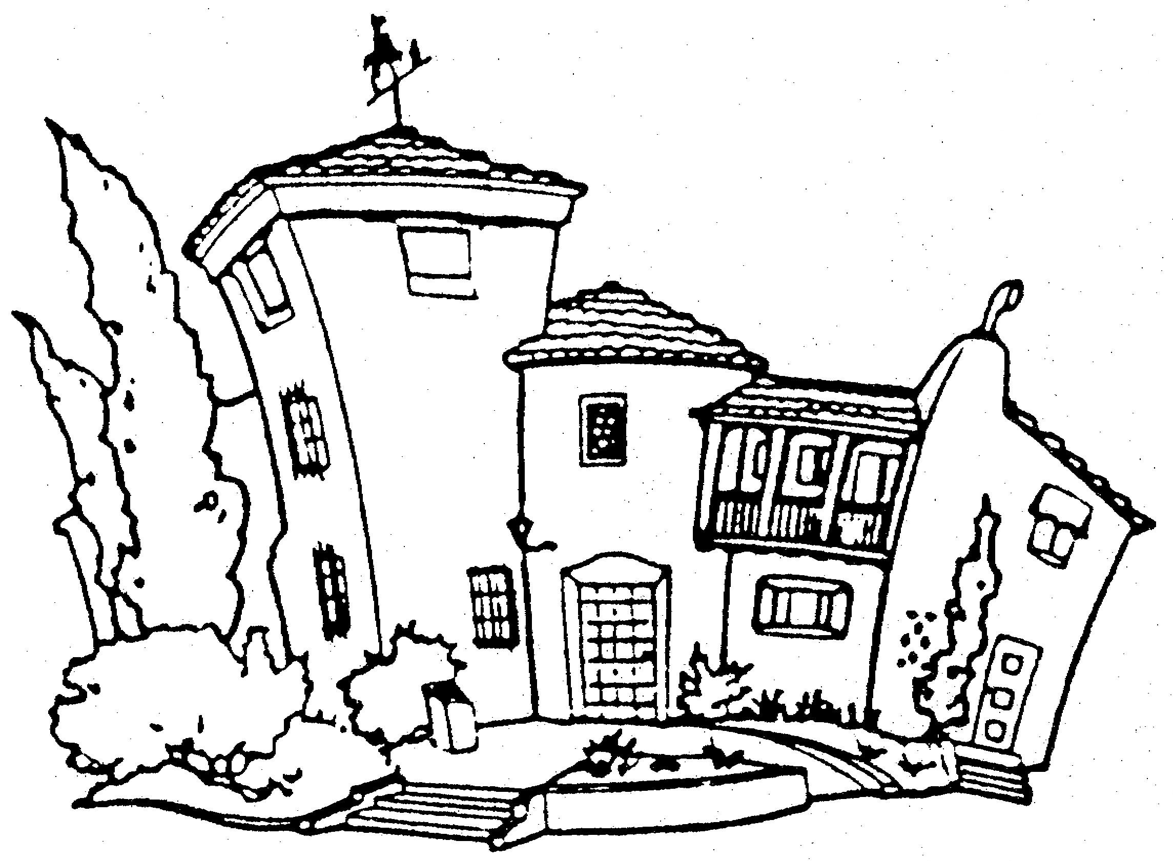
FRIENDS OF HART PARK
BOARD OF DIRECTORS

William S. Hart Park and Museum Friends of Hart Park
24151 San Fernando Road http://www.friendsofhartpark.org P.O. Box 220418
Newhall, CA 91321 Newhall, CA 91322-0418

Name | Title | Address | Phone Numbers | E-Mail
Bob McKinley | President | 23526 Stillwater Pl.  Newhall, CA 91326 | 661 310 2620 Business  661 310 2625 Fax  661 284-1228 Home | rdmckinley@rdmckinleylaw.com
Donna Chipperfield | 1st Vice President | 10010 W. White Fox  Agua Dulce, CA 91350 | 661 268-1649 Home  805 338-6236 Cell  661 268-1082 Fax | dvsews@as.net
Laurene Weste | 2nd Vice President | 22216 Placerita Canyon  Newhall, CA 91321 | 661 254-3823 Home  661 259-2489 Business | LWeste@santa-clarita.com
Becki Basham | Director | 24216 Cross St.  Newhall, CA 91321 | 661 259-6520 Home  661 803-8565 Cell | rabasham@aol.com
Gerry Hogan | Director | 27127 Rio Bosque  Santa Clarita CA 91354 | 661 296-1998 Home | kvgerry@ca.rr.com
Lisa Jaserie | Director | 26379-C N Oak Highland Dr.  Santa Clarita, CA 91321 | 661 251-2224 Home  661 252-3881 Work  661 313-0343 Cell (best bet) | LJaserie@socal.rr.com
Elaine Kaiser | Director | 24700 Valley Street #2061  Santa Clarita, CA 91321 | 661-255-0613 Home | EKaismo@ca.rr.com
Elliott McGrew | Director | 25422 Via Dona Christa  Valencia, CA 91355 | 661 259-9959 Home | ebmcg@sbcglobal.net
Edrie McMeekin | Director | 26813 Oak Garden Court  Santa Clarita, CA 91321 | 661 298-5608 Home | eagts14211@earthlink.net
Dick Meier | Director | 22401 W. Laurel Pl.  Santa Clarita, CA 91390 | 661 297-3482 Home  661 714-3322 Cell | dickmeier@ca.rr.com
Sheila Miller | Director/Secretary | 14931 Minnehaha St.  Mission Hills, CA 91345 | 818 365-8379 Home | sheshe1@gte.net
Lina Schultz | Director | 24811 Meadview Ave.  Newhall, CA 91321 | 661 255-9295 Home  661 210-6959 Cell (for board members only) | rayandlina@sbcglobal.net
Diane Slauson | Director | 23030 Parkview Dr.  Newhall, CA 91321 | 661 260-1964 Home  661 305-1943 Cell | danddparkview@sbcglobal.net
Jack C. Stewart | Director | 27640 Sequoia Glen Dr.  Santa Clarita, CA 91354 | 661 297-5626 Home | kcjack@earthlink.net
Andree Walper | Director | 24738 Choke Cherry Ln.  Newhall, CA 91321 | 661 254-2968 Home  661 286-4166 Work  661 286-4001 Fax | awalper@santa-clarita.com
Liliana West | Director | 21040 Susan Carole Dr.  Santa Clarita, Ca 91350 | 661 263-2216 Home/Home Fax  661 287-3200 x3437 Business  661 313-9558 Cell (best bet) | LilWest@SCVFineHomes.com
Jeff Wheat | Director | 20538 Caitlin Ln.  Saugus, CA 91350 | 661 296-0131 Home | jpwheat@sbcglobal.net
Geoff Williamson | Director/Treasurer | 22670 Devonshire Ct.  Santa Clarita, CA 91350 | 661 255-6833 Home  818 374-7433 Work  661 755-3905 Cell | gcw91350@yahoo.com
Carl Selkin | Vice President, Education  (Ayesha’s Boss) | 900 Exposition Blvd.  Los Angeles, CA 90007 | 213 763-3533 Office  213 744-1042 Fax | cselkin@nhm.org
Ayesha Saletore | Museum Administrator | 24151 N. San Fernando Rd.  Newhall, CA 91321 | 661 254-4584 Office  661 254-6499 Fax | ASaletor@nhm.org
Kimel Conway | Regional Ops. Manager  (David’s Boss) | Regional Facilities Agency  265 Cloverleaf Drive  Baldwin Park, CA 91706 | 626 369-5147 Office | KConway@lacountyparks.org
David Jallo | Park Superintendent | 24151 N. San Fernando Rd.  Newhall, CA 91321 | 661 259-0866 Work  661 253-2170 Fax | DJallo@parks.lacounty.gov

